Sensor Calibration and Linear Regression

First experiment is intended to familiarize with some of the basics of the DAQ system. For many experiments in this course, you will be using a force sensor similar to the one shown in Fig. 1.1. This device is designed to output a voltage that is proportional to the force applied between the hook and the body of the sensor. The Dual-Range Force Sensor is a general-purpose sensor for measuring pushing and pulling forces. The BTA - British Telecom Analog connector cable allows your computer to read this voltage via the myDAQ interface. If Force Sensor is selected as the type of input, the myDAQ will assume it knows how to convert voltage to force and will simply read in units of force (N). However, to illustrate how the interface really works, we will not trust this conversion implicitly and will instead be looking at the raw voltage from the sensor.

The process of determining how voltage corresponds to force is an example of a process called calibration, and Experiment 1 walks you through a manual calibration procedure for this force sensor. This procedure is not the same as the Calibration feature of Vernier dual range force sensor, and the manual calibration described here will be far more accurate than that supplied by the manufacturer. Plastic deformations of the sensor components, changes in ambient conditions, and electrical offset sources may all change between experiments, so to increase the accuracy of your force measurements, you may consider checking the sensor calibration each week that it is used.
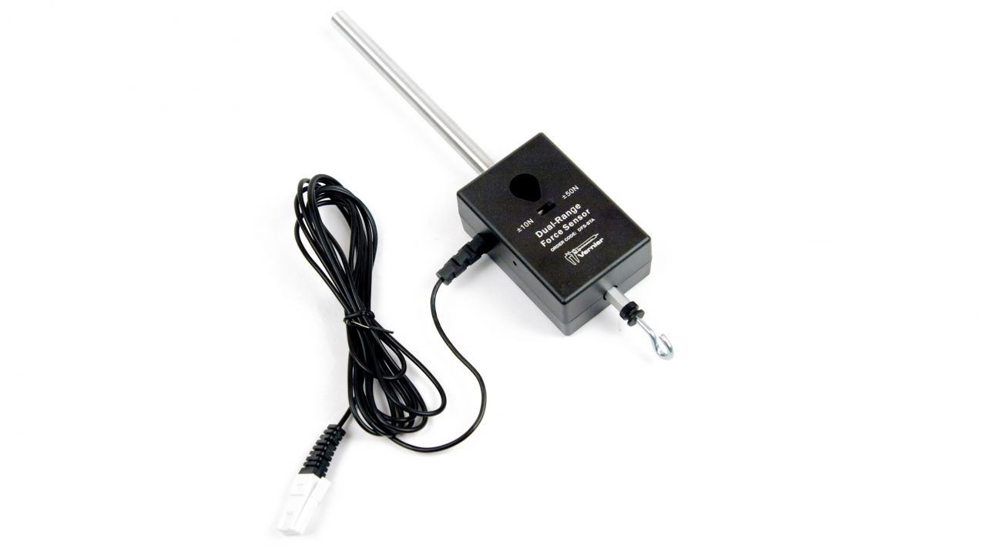
Fig 1.1: Dual Range Force Sensor

Objectives
- Analyze a relation between Voltage and Force of Force Sensor by calibrating
- Determine the uncertainties in the calibration.

Materials Required
- Computer System with LabVIEW & MS Office Excel Installed
- Force Sensor
- Slotted Mass (5 * 10gms) – 2 Sets
- NI myDAQ with Vernier myDAQ Adapter

Hardware & Software Setup
- First, attach the force sensor to a horizontal post or connect Rod to the sensor to hold it along so that the hook hangs vertically downward, appropriate for hanging weights from it.
- Open LabVIEW software for measuring change in voltage for a change in mass.
- To set up the force sensor to read its raw voltage, start your DAQ system using the instructions in Chapter 0 and connect Vernier myDAQ adapter to myDAQ device,
- In LabVIEW Program select Probe selection drop down to read voltage from LabVIEW software by choosing 0-5V Raw Voltage (Do not choose Force Sensor).
- On the Force sensor keep the range as +/- 10N by changing switch on Force sensor
- Run the LabVIEW Program.
- Note the reading of Single scaled value (Green Colored Back Ground) with no mass hanged to it.
- Usually sensor voltage varies from 0-5V where in with no mass hanged to it shows a value of 2.5V. that is 0 corresponds to 10V and 5V corresponds to -10V for a range of +/- 10V
- Hang weights and note corresponding values in Excel sheet as shown in figure – 1.2 Ranging from Masses 0 – 50 gms, Take minimum of 6 Samples.

Fig 1.2: Excel sheet showing fake data entered to explain process of calibration

- Tabulate the value at each mass while weighing as well as unweighing, take the average to get required Voltage.
- Usually Value in Single scaled value will be of 5 digits of precession, Note down corresponding values in excel with minimum of 3 digits of precision in excel sheet.
- As we use known masses we can directly calculate corresponding Force value from F=mg, where m is mass and g is 9.8m/s2.
- As Mass we use are in units of gms. Multiply it with factor of 0.001 to make it Kgs before performing F=mg.
- Thus formula will be F=m * 0.001 * 9.8 to calculate corresponding force for Sensor Voltage.
- Excel calculations will help you to automatically get corresponding values of Force from each mass by typing in “=A3*9.8.*0.001*” (Formula shown for figure 1.1 only) and drag the same to get corresponding values.
- Plot a scattered chart in excel by selecting Force and sensor voltage as shown in figure 1.1, follow Insert-> Chart -> scattered Chart
- Note that Voltage should be on X – axis and Force on y- axis.
- You can also enable axes titles and rename x and y axis details for the same to enhance the visual appearance.

Calculating Uncertainties in a Linear Fit with Excel
- For the chart plotted with data in excel, add Trendline from chart elements, double click on it to get trendline options and enable display equation on chart which is in the form of Y=mX + C. when we select curve as linear in trendline options
- Now go to Data in Excel and select Data Analysis ( If you cannot found it go to File - > Options -> Add-in and select Analysis Toolpak to be active )
- Click on Data analysis which is present in Data-> Data Analysis and select regression and click OK, a window will be opened as shown in below fig 1.3
Fig 1.3: Excel sheet showing Regression analysis

- Input Y range – Sensor Voltage and X Range - Force according to chart analysis.
- Enable Output Range and select any block on excel sheet and click OK
- Now you will get below report of uncertainties as shown in Fig 1.4

Fig 1.4: Excel sheet showing Uncertainties for fake values as on Fig 1.1.

- Uncertainities of equation Y=mX+C can be calculated by Standards errors in excel sheet as shown in fig 1.4.
- C is denoted by Intercept under coefficients, m denoted by X variables under coefficients.
- Uncertainty equations will be noted down on Lab record book/Documentation of Students.
Data Table

Mass in g | Voltage in V  (Weighing) | Voltage in V  (Unweighing) | Average Voltage in V | Force in N
0
10
20
30

Measurement of linear acceleration

This experiment uses an incline and a low-friction cart. If you give the cart a gentle push up the incline, the cart will roll upward, slows down and stop, and then rolls back down, speeding up. Is there a mathematical pattern to the changes in position of the cart? What is the accompanying pattern to the position vs. time graph? Can we extract acceleration from the pattern?
In this experiment, you will use a Motion Detector to collect position data for a cart rolling up and down an incline. Analysis of the graphs of this motion will answer these questions.
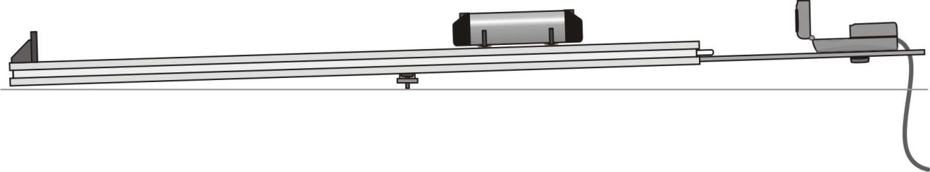
Fig 2.1: Cart on a Ramp to Find out Uniform Acceleration

Aim of the Experiment: To determine acceleration of a body moving along an inclined plane

Materials Required:

- Computer System with LabVIEW & MS Office Excel Installed
- Vernier Dynamic System Carts and Accessories, Vernier Track
- Motion Detector
- NI myDAQ with Vernier myDAQ Adapter

Hardware & Software Setup:

- Connect the Motion Detector to the digital (DIG) port of the interface. Set the Motion Detector sensitivity switch to Track.
- Confirm that your Dynamics Track, Adjustable End Stop, and Motion Detector Bracket are assembled as shown in Figure 1. Adjust the head of the Motion Detector so that it is pointing straight down the track, or angled up just a little.
- Open the Physics Lab Project and Open VI named Uniform Acceleration.
- Place the cart on the track near the end stop. Face the plunger away from the Motion Detector. Run the Program on LabVIEW. Delta t (Δt) that corresponds to the value of sensor is to be set to 0.01. You will notice a clicking sound from the Motion Detector. Wait about a second, then briefly push the cart up the incline, letting it roll freely up nearly to the top, and then back down. Catch the cart as it nears the end stop, or place the cart at one end and release it so that it goes and hits end objection, you can see uniform accelerations when cart moves back after hitting end objection and going back to hit it
- Examine the position vs. time graph. Repeat above step if your position vs. time graph does not show smoothly changing position. Check with your instructor if you are not sure whether you need to repeat data collection.
- You will observe smooth parabolic curve of Position vs Time, zoom the data corresponding to the first segment of the path corresponding to downward motion of the cart by setting appropriate minimum and maximum values along x-axis
- Export the zoomed data to excel and plot a scattered chart
- Right click on the chart and click on add trend line>>select polynomial (2nd order) and click on add equation to chart
- Differentiate equation twice to get the acceleration
- Repeat steps d to i for successive segments corresponding to each upward and downward motion of the cart and find acceleration for each segment
- Find average acceleration for downward and upward motion of the cart. Are they same?

Observation Table:

No. of obs. | Upward motion of the cart |  |  | Downward motion of the cart
No. of obs. | Equation of motion ($y=At^{2}+Bt+y_{0}$) | Acceleration $a_{↑}=2A$ | Mean  $a_{↑}$ (m/s²) | Equation of motion $(y=At^{2}+Bt+y_{0})$ | Acceleration  $$a_{↓}=2A$$ | Mean  $a_{↓}$ (m/s²)
1
2
3
4
5

The acceleration during downward motion of the cart is found to be less than that observed during upward motion of the cart. This may be due to the force of friction that appears during the motion of the cart along the inclined plane.

Finding the coefficient of friction:

The coefficient of rolling friction is
$μ_{r}=\frac{a_{↑}-a_{↓}}{2gcosθ}$ ,

where the angle of inclination, $θ=\sin^{-1}\left(\frac{h_{2}-h_{1}}{100}\right)$
Here $h_{2}-h_{1}$ is the difference in height of the inclined plane from the horizontal at two points 100 cm apart along the inclined plane.

Conclusion:

Linear acceleration of the cart for up and down motions of the cart are found to be ……… and …….., respectively. The difference is due to the force of friction involved during the motion of the cart. The coefficient of rolling friction is found to be ……..

Measurement of acceleration due to gravity

We say an object is in free fall when the only force acting on it is the Earth’s gravitational force. No other forces can be acting; in particular, air resistance must be either absent or so small as to be ignored. When the object in free fall is near the surface of the earth, the gravitational force on it is nearly constant. As a result, an object in free fall accelerates downward at a constant rate.

Physics students measure the acceleration due to gravity using a wide variety of timing methods. In this experiment, you will have the advantage of using a very precise timer and a Photogate. The Photogate has a beam of infrared light that travels from one side to the other. It can detect whenever this beam is blocked. You will drop a piece of clear plastic with evenly spaced black bars on it, called a Picket Fence. As the Picket Fence passes through the Photogate, the interface measures the time from the leading edge of one bar blocking the beam until the leading edge of the next bar blocks the beam. This timing continues as all eight bars pass through the Photogate. The position of the picket fence as it passes through the photo gate versus time graph helps determine the acceleration due to gravity.
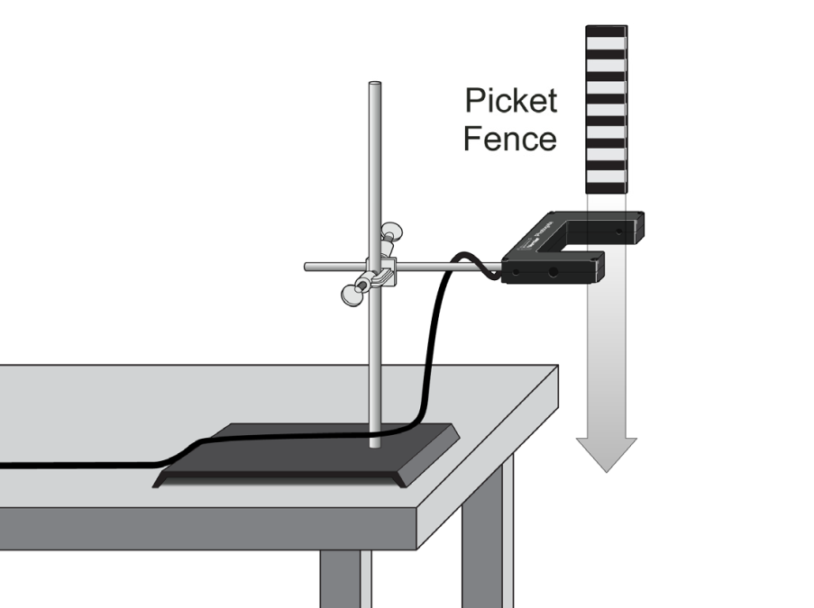
Fig 3.1: Showing Apparatus setup

Aim of the Experiment: To determine the acceleration due to gravity in the laboratory

Materials Required:

- Computer System with LabVIEW & MS Office Excel Installed
- Vernier Photogate with , Picket Fence, Force Plate
- NI myDAQ with Vernier myDAQ Adapter

Procedure for Hardware & Software Setup:

- Fasten the Photogate rigidly to a ring stand so the arms extend horizontally, as shown in figure. To avoid damaging the Picket Fence, provide a soft landing surface (such as carpet).
- Connect the Photogate to the digital (DIG) port of the Vernier myDAQ Adapter
- Make sure red light on the photogate blinks when you place obstacle in between.
- Open LabVIEW Project, and Open Program called as “ Measurement of g”
- Run the program, drop picket fence to pass through Photogate by placing it just 1-5 cm above first black fence.
- Once it passes vertically through photogate, the position versus time graph is displayed on the screen.
- Export the data to excel and plot a scattered chart
- Right click on the chart and click on add trend line>>select polynomial (2nd order) and click on add equation to chart
- Differentiate equation twice to get acceleration due to gravity
- Repeat the steps from e to i 5 times. Take the average value of g

Observation Table:

No. of Trials | Equation of motion ($y=At^{2}+Bt+y_{0}$) | Acceleration due to gravity $g=2A$ | Mean  $g$ (m/s²)
1
2
3
4
5

Conclusion:

The observed value of acceleration due to gravity in Physics lab, ITER, SOAU, Bhubaneswar is found to be ……….. The observed value is independent of the initial velocity of the picket fence during its motion through photogate.

Verification of Newton’s Second & Third Law

How does a cart change its motion when you push and pull on it? You might think that the harder you push on a cart, the faster it goes. Is the cart’s velocity related to the force you apply? Or, is the force related to something else? Also, what does the mass of the cart have to do with how the motion changes? We know that it takes a much harder push to get a heavy cart moving than a lighter one.
A Force Sensor and an Accelerometer will let you measure the force $\vec{F}$ and the acceleration $\vec{a}$ of the cart. Using the observed values Newton’s second law: $\vec{F}=m\vec{a}$ can be verified.

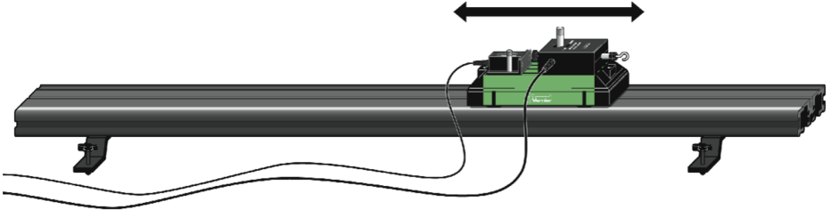
Fig 7.1: Vernier Track System Arranged for Newton’s Second Law

(A) Aim of the Experiment: To verify Newton’s second law of motion and determine unknown mass

Procedure for Hardware & Software Setup:

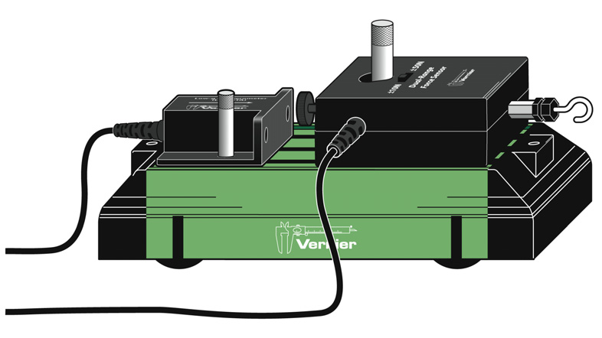
Fig 7.2: Vernier Cart with Sensors Placed

- Set the range switch on the Dual-Range Force Sensor to +/- 10 N.
- Attach the Force Sensor to a Dynamics Cart so you can apply a horizontal force to the hook, directed along the sensitive axis of the sensor
- Attach the Accelerometer so the arrow is horizontal and parallel to the direction that the cart will roll. Orient the arrow so that if you pull on the Force Sensor the cart will move in the direction of the arrow
- You can make use of available screw system to fix sensors on to cart.
- Setup the Sensors and Vernier myDAQ Adapter, Make sure you connect Low-g Accelerometer to Channel 1, Dual- Range Force Sensor to Channel 2.
- Also make sure whether myDAQ connected to LabVIEW properly
- Place the cart on Vernier Track system, run the program, Make sure the length of experiment is 30 s and Range of force sensor is set to +/- 10 N
- Run LabVIEW Program
- Grasp the Force Sensor hook. Click and move the cart up and down perpendicular to ground. Vary the motion so that both small and large forces are applied. Your hand must touch only the hook and not the sensors or cart body.
- Export the data to excel
- Chart the graphs
- Note down at least values of acceleration and force corresponding 10 different time instants.
- Calculate the ratio of the force and acceleration at each time instant
- Now remove low g accelerometer, attach additional mass onto the cart and again attach low g accelerometeras shown in the figure.
- Repeat steps e to m

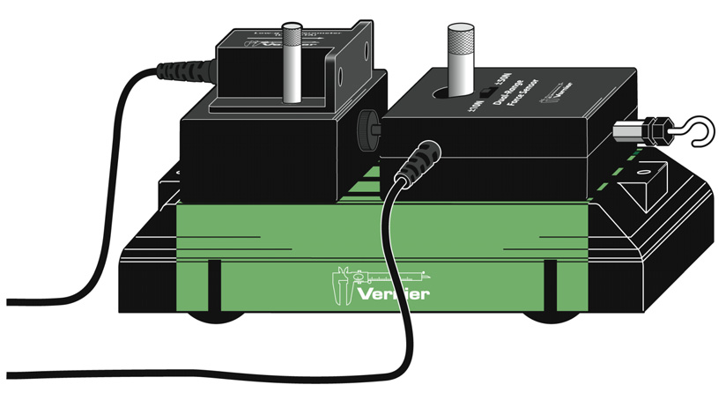
Fig 7.2: Vernier Cart with Sensors & Mass Placed
Observation Table:

No. of Obs. | Force applied on the cart |  |  |  | Force applied on the cart with added mass
No. of Obs. | Time  (s) | Accln. a  (m/s²) | Force F  (N) | F/a  (kg) | Time  (s) | Accln. a  (m/s²) | Force F  (N) | F/a  (kg)

Average F/a when force is applied on the cart = mass of the cart (M₁)=…..
Average F/a for the cart with added mass = mass of the cart plus mass added (M₂)=…..
Unknown mass added on the cart=M₂-M₁=…..

Newton’s Third Law:

You may have learned this statement of Newton’s third law: “To every action there is an equal and opposite reaction.” What does this sentence mean? This experiment will help you investigate this question and verify the law. Unlike Newton’s first two laws of motion, which concern only individual objects, the third law describes an interaction between two objects. For example, what if you pull on your partner’s hand with your hand? To study this interaction, you can use two Force Sensors. As one object (your hand) pushes or pulls on another object (your partner’s hand), the Force Sensors will record those pushes and pulls. They will be related in a very simple way as predicted by Newton’s third law.
The action referred to in the phrase above is the force applied by your hand, and the reaction is the force that is applied by your partner’s hand. Together, they are known as a force pair. This short experiment will show how these forces are related
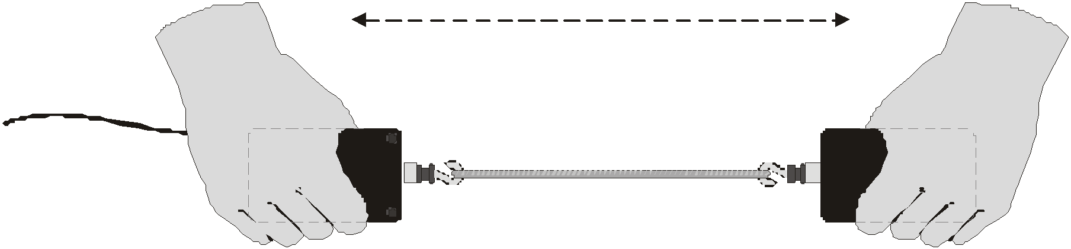

Fig 7.3: Two Force Sensors aligned

Aim of the Experiment: To verify Newton’s third law of motion

Procedure for Hardware and software setup:
- Set the range switch on the Dual-Range Force Sensor to +/- 50 N.
- Attach the Force Sensor to CH1 and CH2 of myDAQ
- Open LabVIEW Program Newtons Third Law
- Make sure range of Sensors in LabVIEW is also +/-50N & Length of experiment is about 30 s
- Pull out the sensors by connecting two hooks as shown in figure
- Observe change in force in two graphs on LabVIEW
- Export the data to excel
- Note down the values of force corresponding to 10 different time instants from CH1 and CH2
- Are you really able to get both readings from CH1 and CH2 same?
- Observe CH1 – CH2 = 0!

No. of Obs. | Force from Sensor_1  F₁₂ (N) | Force from Sensor_2  F₂₁ (N) | F₁₂ – F₂₁  (N)

Conclusion:
- Ratio of the force applied on a given object to its acceleration (F/a) is found to be constant which verifies Newton’s second law of motion. Using this relation the unknown mass added to the cart is found to be …….
- The difference of magnitude of action and reaction forces (F₁₂ and F₂₁) on two bodies is found to be vanishingly small which verifies the Newton’s third law of motion

Verification of Impulse-Momentum Theorem

Impulse J is the product of net average force applied on an object and the duration of time the force is applied.

Impulse-Momentum Theorem: The change in momentum of particle during a time interval equals the impulse of the net force that acts on the particle during that interval.
$$\vec{J}={\vec{F}}_{av}\left(t_{2}-t_{1}\right)=m({\vec{v}}_{2}-{\vec{v}}_{1})$$

We will only consider motion and forces along a straight line. For this experiment, a Dynamic Cart will roll along a level track. Its momentum will change as it collides with a hoop spring. The hoop will compress and apply an increasing force until the cart stops. The cart then changes direction as the hoop expands back to its original shape. The force applied by the spring is measured by a Dual-Range Force Sensor. The cart velocity throughout the motion is measured with a Motion Detector. You will then use data-collection software to find the impulse and verify impulse-momentum theorem.

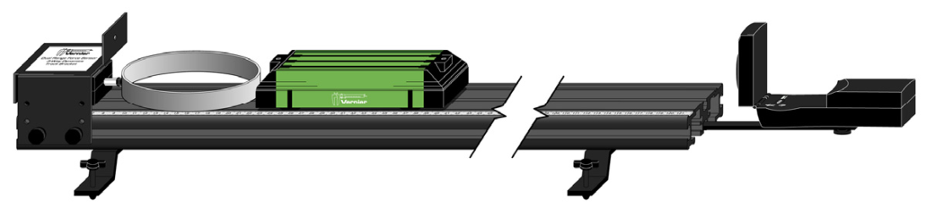
Fig 5.1: Apparatus for Momentum and Impulse

Aim of the Experiment: To verify the Impulse-Momentum Theorem

Materials Required:
- Computer System with LabVIEW & MS Office Excel Installed
- Vernier Motion Detector
- Vernier Dynamics System,
- Vernier Track
- Bumper and Launcher Kit
- NI myDAQ with Vernier myDAQ Adapter

Procedure for Hardware & Software Setup
- Measure the mass of the cart and record the value in the data table.
- Attach the Motion Detector and bracket to one end of the Dynamics Track as shown in fig 5.1.
- Set the range switch on the Dual-Range Force Sensor to 10 N. Replace the hook end of the Dual-Range Force Sensor with the hoop spring bumper. Attach the Dual-Range Force Sensor to the bumper launcher assembly as shown in Figure 2. Then attach the bumper launcher assembly to the end of the track opposite the Motion Detector.
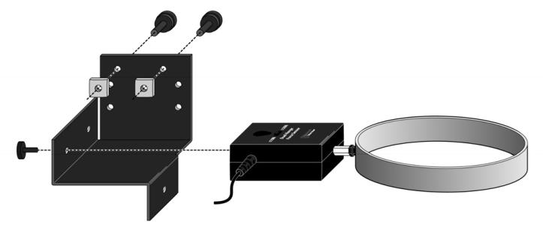
Figure 5.2 Connect the Dual-Range Force Sensor to the bumper launcher assembly.
Note: Shown inverted from how the sensor and assembly are attached to the track

- Place the track on a level surface. Confirm that the track is level by placing the low-friction cart on the track and releasing it from rest. It should not roll. If necessary, adjust the track to level it.
- Set the Motion Detector sensitivity switch to Track. Connect the Motion Detector to a digital (DIG) port of the interface. Connect the Dual-Range Force Sensor to Channel 1 of the interface
- Open Physics lab LabVIEW Project and Open program named Momentum and Impulse
- Remove all force from the Dual-Range Force Sensor by adjusting intercept value in block diagram.
- Practice releasing the cart so it rolls toward the hoop spring, bounces gently, and returns to your hand. The Dual-Range Force Sensor must not shift, and the cart must stay on the track. Keep your hands away from the space between the cart and the Motion Detector.
- Position the cart so that the front of the cart is approximately 50 cm from the spring.
- Study your graphs to determine if the run was useful.
- Inspect the force data. If the peak exceeds 10 N, then the applied force is too large. Roll the cart with a lower initial speed.
- Confirm that the Motion Detector detects the cart throughout its travel and that you can see a region of constant velocity before and after the impact. If necessary, repeat data collection.
- Once you have made a run with good position, velocity, and force graphs, analyze your data to test the impulse-momentum theorem, you need the velocity before and after the impulse, Vf is the final velocity and Vi is the initial velocity with which cart hits hoof spring
- Now you will calculate the value of the impulse by finding out average of force when cart is hitting hoop spring, zoom to get required values, export to excel and find out average force. Also find time taken which is dt.
- On the velocity vs. time graph, find an interval corresponding to a time before and after the impulse, when the cart was moving at approximately constant speed toward the Dual- Range Force Sensor, find change in velocity.
- Record the data for three trails
- Inelastic Collisions: Replace the hoop spring bumper with one of the clay holders from the Bumper and Launcher Kit. Attach cone-shaped pieces of clay to both the clay holder and to the front of the cart, as shown in Figure.
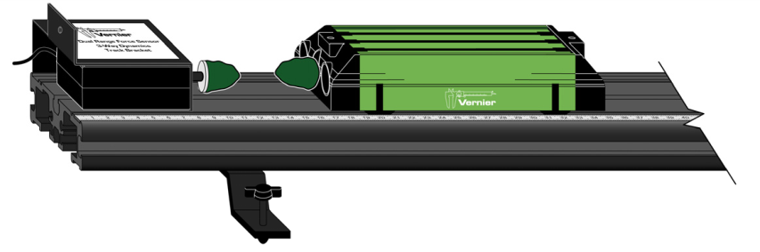
Fig 5.1: Apparatus for Momentum and Impulse – Inelastic Collisions
- Now calibrate force sensor to get zero, practice launching the cart with your finger so that when the clay on the front of the cart collides with the clay of dual range force sensor, cart comes to a stop without bouncing
- Make sure you position the cart 50 cm away before moving towards force sensor
- Study your graphs if the run was successful.
- Repeat steps m to r and run for three trails

Data Table:
Mass of Cart | Kg

NON-CALCULUS VERSION
Trial | Final velocity  vf (m/s) | Initial velocity  vi (m/s) | Change of velocity  Δv(m/s) | Average force  F(N) | Duration of impulse  Δt (s) | Impulse FΔt (N s) | Change in momentum (kg m /s) or (N s) | Difference between Impulse and Change in momentum
Elastic 1
2
3
Inelastic 1
2
3

Conclusion:

The Impulse of a force acting on the cart during the interval is found to be equal to the change in its momentum both in elastic and inelastic collisions. This verifies the Impulse-Momentum Theorem.

Verification of principle of Conservation of Mechanical Energy

We can describe an oscillating mass in terms of its position, velocity, and acceleration as a function of time. We can also describe the system from an energy perspective. In this experiment, you will measure the position and velocity as a function of time for an oscillating mass and spring system, and from those data, plot the kinetic and potential energies of the system.

In vertical oscillations, the spring-mass system possesses energy three forms (kinetic energy (E_{k}), elastic potential energy (E_{p}) and gravitational potential energy). For mass m moving with velocity

$$E_{K}=\frac{1}{2}mv^{2}$$

The elastic potential energy of the spring stretched/compressed by y is
$$E_{P}=\frac{1}{2}ky^{2}$$
where, k is the spring constant given by $k=\frac{mg}{y}$ when the spring is stretched by y with a load mg

The mass and spring system also has gravitational potential energy , but we do not have to include the gravitational potential energy term if we measure the spring length from the hanging equilibrium position. We can then concentrate on the exchange of energy between kinetic energy and elastic potential energy.
If there are no other forces are acting on the system, then the principle of conservation of energy tells us that $E_{K}+E_{P}=constant$ which can be verified experimentally.
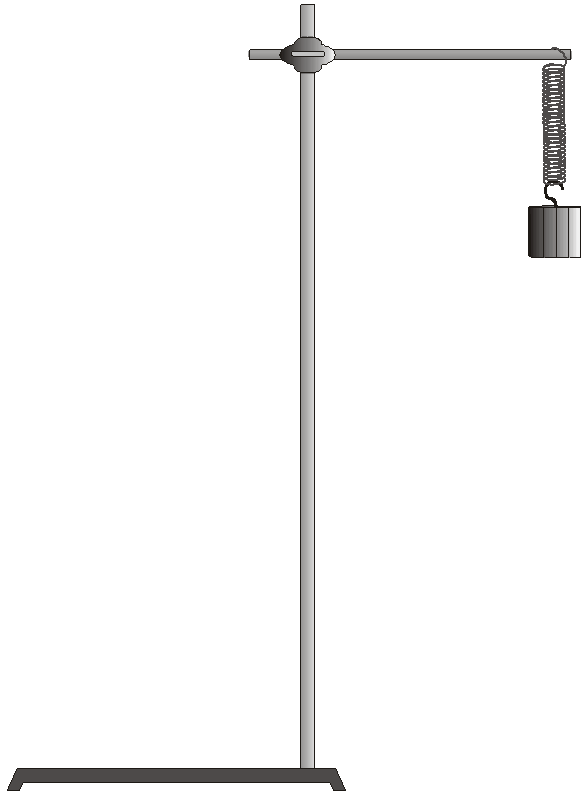

Fig 4.1: Apparatus for Conservation of Mechanical Energy

Aim of the Experiment: To verify the principle of conservation of mechanical energy for a vertically oscillating mass and spring system

Materials Required:

- Computer System with LabVIEW & MS Office Excel Installed
- Vernier Motion Detector
- Slotted Mass – 100 gms to 500 gms – 1 set
- Springs 15 N/m – twisted ties
- Physics retort stand or Ring stand
- NI myDAQ with Vernier myDAQ Adapter

Procedure for Hardware & Software Setup:

- Mount the 300 g mass and spring, as shown in Figure. Securely fasten the 300 g mass to the spring, and the spring to the rod, using twist ties so that mass cannot fall.
- Connect the Motion Detector to a digital (DIG) port of the interface. Set the Motion Detector sensitivity switch to Ball/Walk. And connect to Vernier myDAQ Adapter also
- Position the Motion Detector directly below the hanging mass, taking care that no extraneous objects could send reflections back to the detector. Protect the Motion Detector by placing a wire basket over the detector. The mass should be about 30 cm above the detector when it is at rest. Using amplitudes of 5 cm or less will then keep the mass at least 15 cm above the Motion Detector.
- Open Physics Lab LabVIEW Project and open Conservation of Mechanical Energy.
- Run program and find out distance between mass and motion detector which is nothing but zero calibration value.
- Enter Zero calibration value to make mean position of Motion sensor value to be zero, and enter values of k in N/m and mass in kg and move the mass upward maximum to 5 cm and leave the system to oscillate.
- Take care that the mass does not swing laterally.
- Click Run to record position and velocity data.
- View the graphs of E_{K} versus time, E_{P} versus time and total energy E, versus time on the screen
- View the graphs of E_{K} versus y, E_{P} versus y, E versus y
- Zoom position and velocity data corresponding to 3 consecutive oscillations by setting appropriate minimum and maximum values along time axis.
- Export the zoomed data to excel and plot a scattered chart. Note down at least 10 values of the position and velocity in equal time intervals during each cycle
- Calculate elastic potential energy and kinetic energy corresponding to observed position and velocity respectively
- Plot of E_{K} versus time, E_{P} versus time and total energy E, versus time on the graph sheet
- Plot the graphs of E_{K} versus y, E_{P} versus y, E versus y on the graph sheet

Observation Table:

No. of obs. | Time, t  (s) | Position, y (m) | Velocity, v (m/s) | E_{K}  (J) | E_{P}  (J) | E  (J)
1
2
3
.
.
.
.
30

Conclusion:

During the vertical oscillation of the spring the sum total of kinetic and elastic potential energy of the mass and spring system remains almost constant. The small decrease in the total energy is due to the damping factors affecting the simple harmonic motion of the system.

Measurement of frequency of Harmonic Oscillator

A vibrating tuning fork, a moving child’s playground swing, and the loudspeaker in a radio are all examples of physical vibrations. There are also electrical and acoustical vibrations, such as radio signals and the sound you get when blowing across the top of an open bottle.
One simple system that vibrates is a mass hanging from a spring. The force applied by an ideal spring is proportional to how much it is stretched or compressed. The up and down motion of the mass and spring system is simple harmonic and the instantaneous position of the system can be modeled with
$$y\left(t\right)=Asin(2πft+φ)$$
Here, y is the vertical displacement from the equilibrium position, A, the amplitude, f the frequency and ϕ the phase constant of oscillation.
The oscillator is a mass, m hanging from a spring which is connected to Force Sensor as shown in Figure below. Here we are required to measure the spring constant, k which would help us to predict the frequency of oscillation which is related to k as
$$f=\frac{1}{2π}\sqrt{\frac{k}{m}}$$

Fig 6.1: Showing Apparatus setup

The force sensor from which the weight hangs provides readout of the oscillatory motion. Oscillate the mass by gently lifting it maximum upto 5 cm from its equilibrium position to ensure the oscillations in vertical direction only.

Aim of the Experiment: To determine the frequency of an oscillating mass and spring system and compare it with the value predicted from the equation:
$$f=\frac{1}{2π}\sqrt{\frac{k}{m}}$$
Materials Required:

- Computer System with LabVIEW & MS Office Excel Installed
- Vernier Dual range Force Sensor
- Physics Retort Stand or Ring Stand
- Slotted Mass – 50 gms to 250 gms – 1 set
- Springs 15 N/m – twisted ties
- NI myDAQ with Vernier myDAQ Adapter

Procedure for Hardware & Software Setup:

- Fasten the Force sensor rigidly to a ring stand and put a spring to force sensor hook and tie hook and spring with a small string so that it will not move while oscillating. ( Some one can hold stand steady )
- Connect force sensor to Vernier myDAQ adapter to CH1 and try to see If you are able to oscillate mass hanged to the force sensor through spring.
- Use Hookes Law $\left|F\right|=mg=kx$ to determine the spring constant $k_{1}$ for a spring elongated by x under the load mg. Similarly find the spring constant $k_{2}$ of another spring
- Substitute the value of k & m in the equation:
$$f=\frac{1}{2π}\sqrt{\frac{k}{m}}$$
to find the frequency of oscillation.
- Now attach a known mass (50, 100 gram), lift the mass upward 4-7 cm and release it gently. Take care to see that mass oscillates along a vertical line only.
- Run LabVIEW Program named Harmonic Oscillator – SHM.vi by opening Physics Lab Project
- Examine the graphs in LabVIEW and note down reading of frequency from the screen
- Export the data to excel, zoom it and find the frequency of oscillation from the plot
- Repeat steps e to i by changing the mass
- Connect both the springs in series and apply 50 gram load and repeat steps e to h

Observation Table:

Spring | Mass  (g) | Time for 5 oscillations  (s) | Time Period  (s) | Observed Frequency f_{o} (Hz) | Predicted Frequency f  (Hz)
A | 50  100
B | 50  100
A & B in series | 50

Calculations:

The effective spring constant k for two springs in series in terms of spring constants k₁ and k₂ of individual springs is given by
$k=\frac{k_{1}k_{2}}{k_{1}+k_{2}}$
The observed frequency f_{o} of vibration of two springs in series vibrating under load mg is given by
$f_{0}=\frac{1}{2π}\sqrt{\frac{k}{m}}$`
from which the effective spring constant k is found to be $k=4π^{2}f_{0}^{2}m$ which should match with the value obtained from $k=\frac{k_{1}k_{2}}{k_{1}+k_{2}}$

Conclusion:

The vibration of the spring and mass system is found to be simple harmonic with its observed frequency nearly equal to theoretically predicted value. The effective spring constant, k of two springs in series vibrating under certain load mg is found to be equal to the value of $\frac{k_{1}k_{2}}{k_{1}+k_{2}}$ as expected.

Measurement of wavelength and velocity

of waves on a vibrating string

When you shake a string, a pulse travels down its length. When it reaches the end, the pulse can be reflected. A series of regularly occurring pulses will generate traveling waves that, after reflection from the other end, will interfere with the incoming wave. Under suitable conditions, the superposition of these waves traveling in opposite directions gives rise to what is known as “standing wave.” In this lab you will investigate various factors that give rise to this phenomenon.

Aim of the Experiment: To determine the wavelength and velocity of the wave along a vibrating string

Materials Required:

- A computer with the Vernier Power Amplifier Computer program
- Vernier Power Amplifier
- Vernier Power Amplifier Accessory Speaker
- Vernier Ultra Pulley and support rod
- 3–4 m length of rope or a tightly coiled spring (“snaky”)
- Slotted Mass (5 X 50 gram)
- meter stick or metric tape
- Elastic cord.
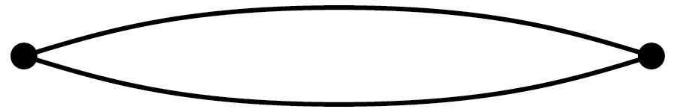

Fig 8.1: Standing wave on string

This is the simplest standing wave one can set up on a string or spring held at both ends. It is known as the fundamental frequency of vibration (also called the first harmonic, f1). It is the primary mode of vibration of a guitar string when it is plucked in the middle.
Increase the rate at which you shake it until you obtain a waveform with a node in the middle as well as at either end. This waveform is often called the second harmonic, f2. At this rate of shaking (frequency) you are producing a complete wave. The distance between the two fixed ends is the wavelength, of the standing wave.

Procedure for Setting up Standing Wave:

Set up the apparatus as shown in Figure 8.2. Attach the hook that comes with the Power Amplifier accessory Speaker to the speaker. Tie one end of the elastic cord to the hook and the other end to a support rod. The elastic cord should be stretched just tightly enough that it does not sag visibly, but is not too taut (the length of the cord should be 60–80 cm). Record the length of the cord. Turn on the power to the Power Amplifier.

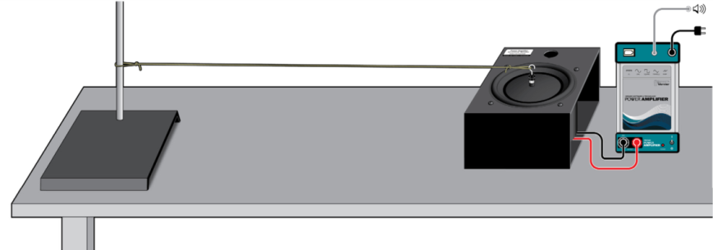

Fig 8.2: Standing waves on string apparatus

Connect the speaker leads to the Power Amplifier, then choose Power amplifier computer program which was pre-installed in Computer to drive the speaker. Start >> Program files >> Power Amp
- Use the mini stereo cable that came with the Power Amplifier to connect the speaker out port on your computer and the Audio In port on the amplifier.
- Set the computer’s sound output on and at maximum volume.
- Start the Vernier Power Amplifier computer program.
- The default value of 2.0 V is suitable. Change the initial frequency to about 20 Hz. To adjust the frequency, use the up and down arrows or use the frequency control box to enter the desired value.
- Click Start.
- Adjust the frequency until you have generated the fundamental mode of vibration (greatest amplitude in the middle and nodes only at the ends) on the cord. Note: If you need to stop the vibration of the string, disconnect a lead from the amplifier to the speaker rather than turning off the amplifier. As you approach the optimal frequency, make small adjustments and wait a few seconds after each adjustment to allow the system to stabilize. To ensure that you have reached the optimal frequency, increase the frequency gradually until the amplitude begins to decrease, then reduce it until the amplitude again appears to have reached its maximum. Record this frequency as f1 in your data table.
- Without changing the length of the cord, increase the driving frequency gradually until the second harmonic, f2, appears. Record this frequency in your data table. Note how the amplitude of the antinodes compares to that in the fundamental. Sketch the waveform that you observe between the two fixed points at the ends of the cord.
- Use the values of f1 and f2 to predict the value of f3. Set the driving frequency to this value, then adjust the frequency until the amplitude of the standing wave is at a maximum. Record this frequency in your data table. Note where the nodes appear on the cord. Sketch the waveform that you observe; be sure to keep the distance between the ends of the strings unchanged. How many waves are visible, continue this process until you have generated the fifth harmonic, f5 on the cord.
- Stop driving the speaker and turn off the power amplifier.

Evaluation of Data:

- Compare the frequencies of the higher harmonics (f2, f3, etc.) to that of the fundamental, f1.
- Write a statement that describes the relationship you find.
- From the input frequency and corresponding observed wavelength calculate the speed of the wave
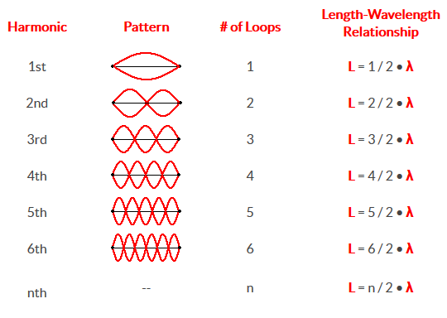
Fig 8.3: Data table for relation between length and wavelength
Observation Table:
Length of the string……..

Harmonic | Frequency f (Hz) | Wavelength (m) | Velocity (m/s)
1st
2nd
3rd
4th
5th

Speed of waves on String:

Speed of the wave on a vibrating string is given by $v=\sqrt{\frac{T}{μ}}$ , where T is the tension along the string and μ is the linear density of the string

- Replace the elastic cord used in Part 1 with a less stretchy braided string. Find the mass and length of your string to calculate the linear density in kg/m; record this value in your data table.
- Tie one end to the hook on the speaker and the other end to a very light mass hanger. Suspend the string over a pulley, as shown in Figure 8.4. Use the lightest masses you have available to keep the string from sagging. Measure the length of the string between the hook and the point of contact with the pulley.
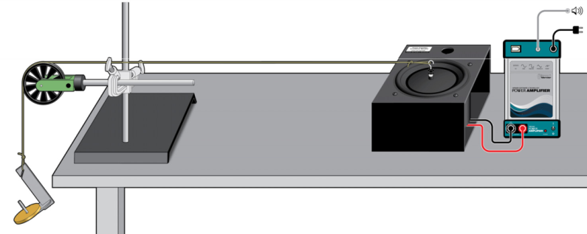
Fig 8.4: Apparatus

- As you did in Part 1, adjust the frequency of the driver so as to set up the second harmonic, f2, (one complete wave) in the string. Record this frequency.
- Increase the mass on the hanger in steps of 50 gram and adjust the frequency in each case to set up the second harmonic.
- Increase the frequency until the second harmonic again appears. As you did in Part 1, take steps to ensure that you have reached the optimal frequency. Record this value as well as the tension provided by the hanging mass.
- Continue adding mass to the hanger to increase the tension on the string and adjusting the frequency to produce the second harmonic (one complete wave) until you have seven or eight data pairs. When you are done, turn off the driver.
- From the input frequency and corresponding observed wavelength calculate the speed of the wave for each applied load
- Plot T versus $v^{2}$ which should be straight line passing through origin.
- From the slope of the line, obtain linear density of the string

Observation Table:

No. of Obs. | Tension T  (N) | Frequency f (Hz) | Wavelength λ  (m) | Velocity $v$  (m/s) | $$v^{2}$$  (m/s)²
1
2
3
4
5

Conclusion:

- The velocity of wave along the elastic string is found to be independent of frequency of vibration as expected.
- The velocity of the wave along the vibrating string is found to be proportional to the square root of tension along the string for given mass per unit length of the string as shown in the graph.
- The linear density of the string is found to be ----------

